Species Distribution across sampling sites

The figures below illustrate the distribution of Anguilla species across the sampling sites. Anguilla bengalensis dominated the catch in all sites having more than 75% of all Anguilla species caught in the SBE1 and SBE2 which were the first two sites. Anguilla mossambica dominated the third sampling site by having more than 50% of all Anguilla species caught. Anguilla marmorata was only caught in the fourth sampling site and comprised only 5% of all species caught. The Anguilla bengalensis dominated the catch in site four (SBE4)

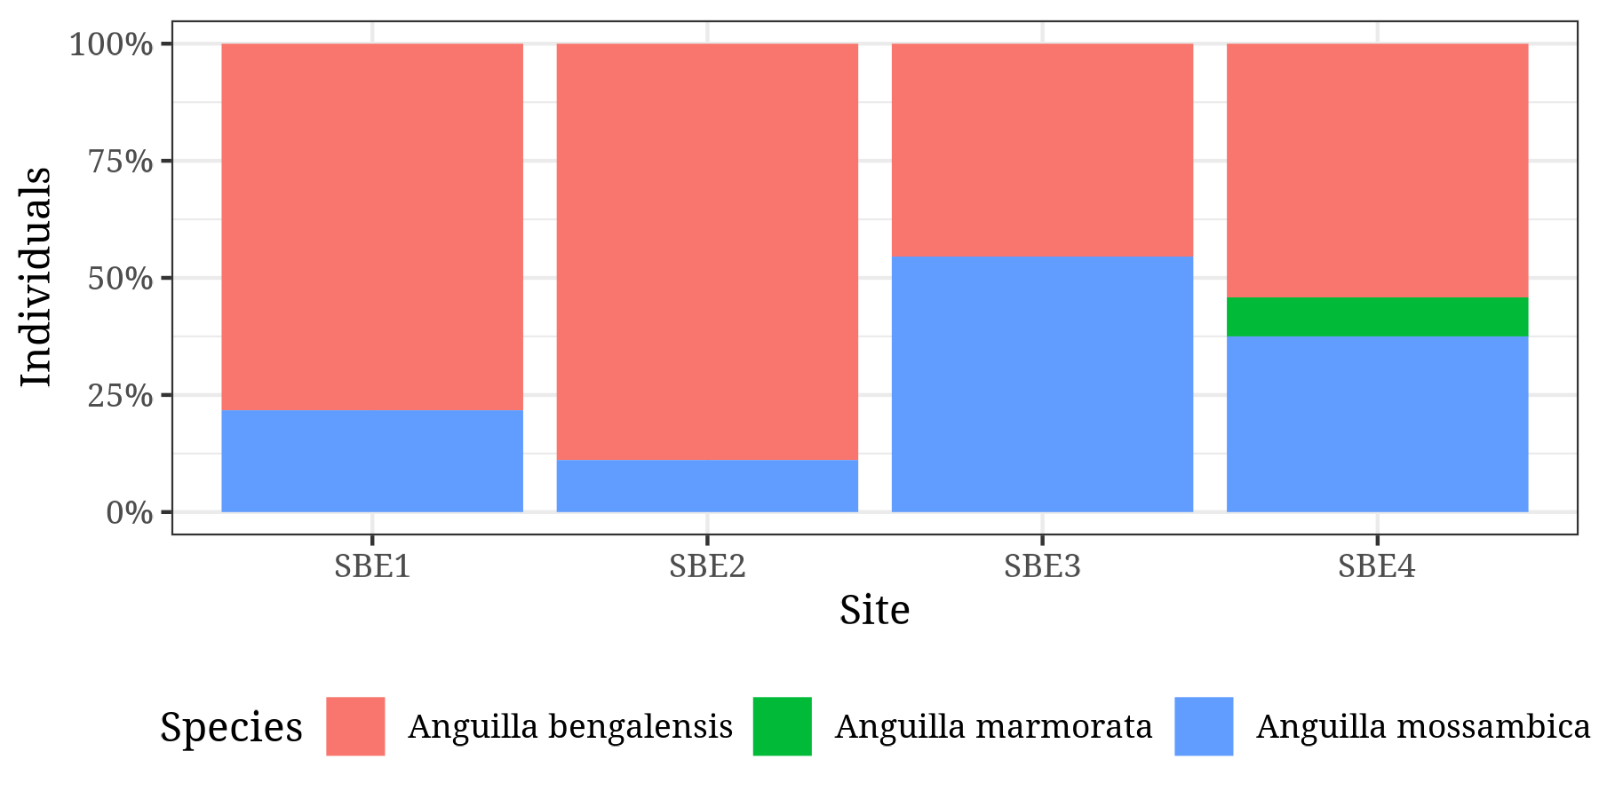

Dodged figure

